Statistical analysis of groundwater contaminants at Hidalgo county using Python’s matplotlib

Dwight Zedric Q. Capus  
Ocean, Coastal, and Earth Sciences MS program

University of Texas Rio Grande Valley   
Edinburg, TX

April 4, 2021

**Abstract**

Many living things rely on groundwater as part of their sustenance and therefore, this makes it the most important freshwater asset in the United States. Groundwater has also been a vital factor for water security and expanding nourishment for the population. This research will compile, map and analyze the groundwater contaminants in Hidalgo County, Texas. By using the packages of Matplotlib and Cartopy of Python, we will be able to analyze the occurrences of contaminants at Hidalgo county. Along with constructing a bar plot and a map comparing each contaminant, a time-series plot of yearly cases and types of impurities will be generated to understand and compare each contaminant. This study is significant because it could provide locals with knowledge and awareness about the problem and could also be utilized as additional data for local and regional databases.

**Introduction**

Groundwater is the most important freshwater asset. Many inhabitants of this nation rely upon this asset for their water needs. Groundwater has been a significant part of expanding nourishment generation and accomplishing water security. Additionally, groundwater has an exceedingly reliable water supply business, households, horticulture, and mechanical needs(Gangwar et al., 2021). The groundwater of the Gulf Coast Aquifer in the Lower Rio Grande Valley of South Texas has limited water supply for domestic, municipal, and agricultural usage. Additionally, in Lower Rio Grande Valley, groundwater in most areas often does not meet drinking water or irrigation standard. Groundwater in the valley is mostly slightly saline, about 1000 to 3000 milligrams per liter of Total Dissolved Solids, with the local occurrence of high boron, chloride, sodium, and nitrate(Chowdhury & Mace, 2007).

Groundwater contamination is generally defiance as any harmful alteration of the naturally occurring quality of groundwater. However, in this study, the definitions is limited to the contamination that is associated with activities that fall under the responsibility of the contributing agencies and affecting usable-quality groundwater and does not include naturally occurring groundwater conditions such as high mineralization that may exceed recognized standards for public usage (Texas Groundwater Protection Committee, 2020)Figure 1 shows an example of groundwater contamination (mainly hydrocarbon contaminants), locally known as “Mcallen Plume”. This study aims to analyze the occurrences and prevalence of groundwater contamination at Hidalgo County, Texas. This paper will use Python’s Matplotlib package to generate the plots and Cartopy for maps. Furthermore, the scope of this study includes closed and open cases reported at Joint Groundwater Monitoring and Contamination Report from 2019, 2018, and 2017.

Research questions.

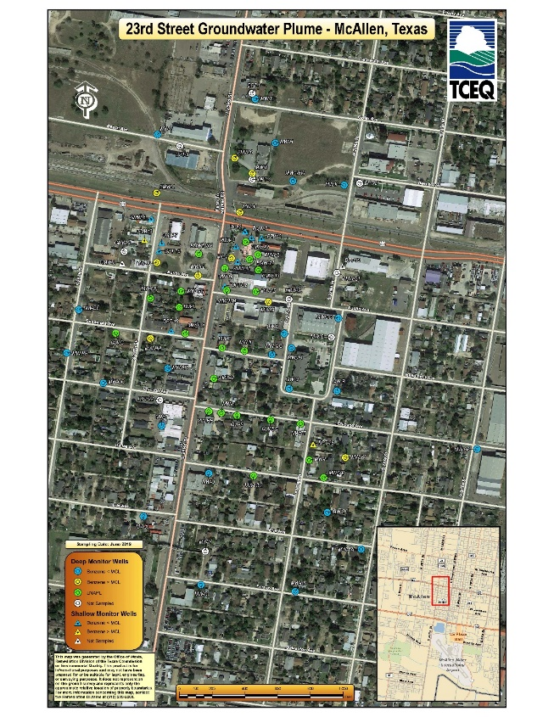

Figure 1 Mcallen Plume (TCEQ, n.d.)

**Research questions**

This paper aims to answer the following questions:

1) What is the distribution of different types of contaminants in the area?

2) How does the contamination occurrences changes over time

**Proposed Methods**

To answer the questions above, the study will utilize the Excel worksheet to organize the data and use Python Jupyterlab to plot and analyze the data. The data will be sourced from Joint Groundwater Monitoring and Contamination Report 2019, 2018, and 2017. After organizing the data, data will then be plotted for distribution of contaminants using time-series plots. Data will be uploaded to the kernel as a dataframe. Python's Matplotlib package will be loaded into the kernel to create the plots. This paper will look at the total cases, open cases, and closed cases changes over time (yearly/monthly). Different types of contaminants will also be plotted to understand their distribution using a time-series plot and bar plots. Cases of contaminant will be plotted on the map of the area using python’s cartopy package.

**Timeline:**

4/4/2021 – Submission of proposal

4/5 – 4/10 – Data compilation in Excel

4/11 – 4/20 – Plotting of the data (Line chart and Bar Charts)

4/21- 4/25 – Groundwater contaminants map of Hidalgo county

4/26 – 4/30 – Begin writing the final paper and result, and creation of power point presentation

5/1-5/2- Submission of final paper to Github

5/3 – Final presentation uploaded to Github

**Significance of research**

This research provides an illustration of groundwater contaminants occurrence in Hidalgo county that can quickly provide knowledge and awareness to the residents of the area. This paper can be used as additional data for local databases and future regional reports.

**References**

Chowdhury, A., & Mace, R. E. (2007). *Groundwater Resource Evaluation and Availability Model of the Gulf Coast Aquifer in the Lower Rio Grande Valley of Texas* (No. 368). Texas Water Development Board. https://www.twdb.texas.gov/publications/reports/numbered_reports/doc/R368/R368_GulfCoastGAM.pdf

Gangwar, S., Chauhan, M. S., & Singh, D. (2021). A Supervising Grid Model for Identification of Groundwater Pollute. In M. S. Chauhan & C. S. P. Ojha (Eds.), *The Ganga River Basin: A Hydrometeorological Approach* (pp. 53–66). Springer International Publishing. https://doi.org/10.1007/978-3-030-60869-9_4

TCEQ. (n.d.). *23rd Street Groundwater Plume in McAllen, Hidalgo County, TX*. Retrieved April 4, 2021, from https://www.tceq.texas.gov/remediation/sites/23rdstreet/23rd%20Street

Texas Groundwater Protection Committee. (2020). *Joint Groundwater Monitoring and Contamination Report—2019 Prepared by the Texas Groundwater Protection Com*. Texas Commission on Environmental Quality.

\section{Conclusion}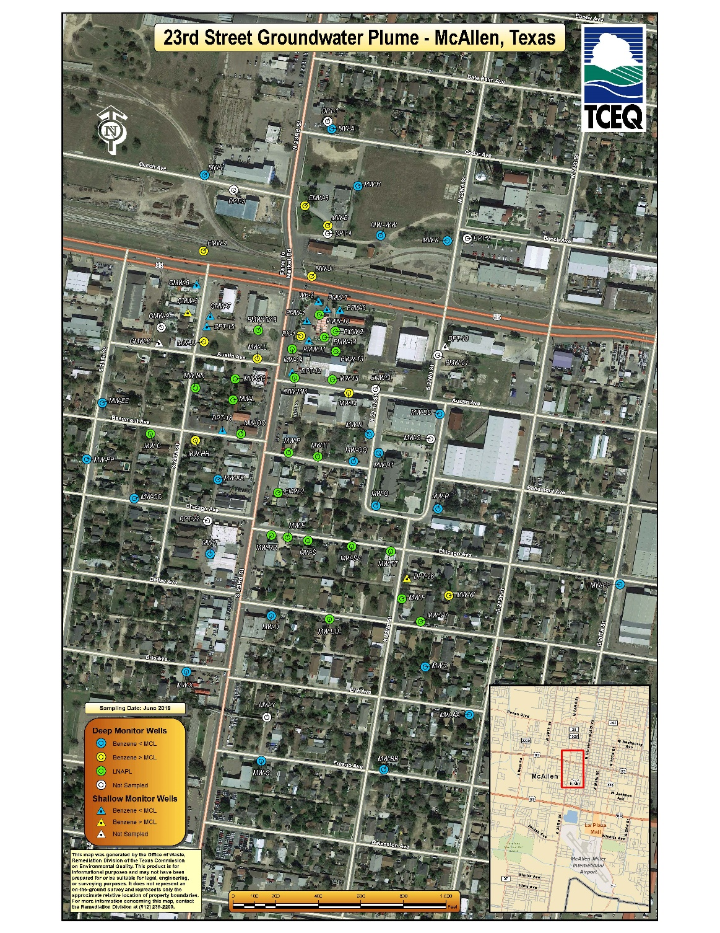

Anthropogenic sources of contamination in groundwater are those chemical constituents detected in groundwater supplies that are the result of human activity and for the purposes of this report, have no natural source of occurrence. There are numerous sources for this type of impact on groundwater. The purpose of this report is to provide the Texas Water Development Board (TWDB) and Regional Water Planning Groups (RWPGs) with a centralized source of information that will be useful in the development of the Regional Water Plans and the State Water Plan